**REPORT**

**Capstone Project - The Battle of Chinese Restaurant Between Neighbourhood**

**Introduction:**

New York City's is a large and ethnically diverse metropolis. It is the largest city in the United States with a long history of international immigration. New York City was home to nearly 8.5 million people in 2014, accounting for over 40% of the population of New York State and a slightly lower percentage of the New York metropolitan area, home to approximately 23.6 million. Over the last decade the city has been growing faster than the region. The New York region continues to be by far the leading metropolitan gateway for legal immigrants admitted into the United States.

With its diverse culture, comes diverse food items. There are many restaurants in New York City, each belonging to different categories like Chinese, Indian, and French etc.

**Problem:**

To find the answers to the following questions:

1. What are best location in New York City for Chinese restaurant?

2. Which areas have potential Chinese restaurant market?

3. Which all areas lack Chinese restaurants?

4. Which is the best Chinese restaurant in New York City?

**Data Section:**

For this project we want the following data:

* New York City data that contains list Boroughs, Neighbourhoods along with their latitude and longitude.
* Data source : <https://cocl.us/new_york_dataset>
* Description: This data set contains the required information. And we will use this data set to explore various neighbourhoods of New York City
* Chinese restaurants in each neighbourhood of New York City.
* Data source : Foursquare API
* Description: By using this API we will get all the venues in each neighbourhood. We can filter these venues to get only Chinese restaurants.
* GeoSpace data
* Data source : <https://data.cityofnewyork.us/City-Government/Borough-Boundaries/tqmj-j8zm>
* Description: By using this geo space data we will get the New York Borough boundaries that will help us visualize choropleth map.

**Methodology:**

1. We begin by collecting the New York city data from the following link "[https://cocl.us/new_york_dataset"](https://cocl.us/new_york_dataset%22)
2. We will find all venues for each neighbourhood using Foursquare API

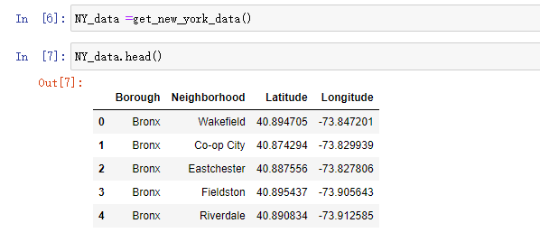

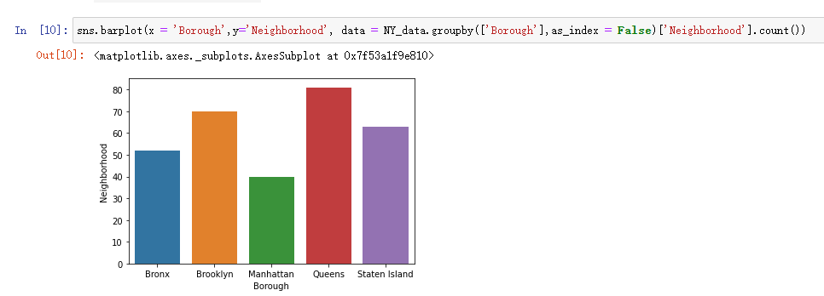

1. We will then filter out all venues with Chinese restaurant for further analysis.

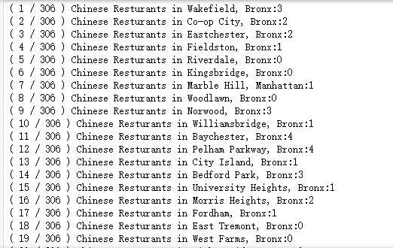

1. Next using Foursquare API, we will find the Ratings, Tips, and Number of Likes for all the Chinese Restaurants.

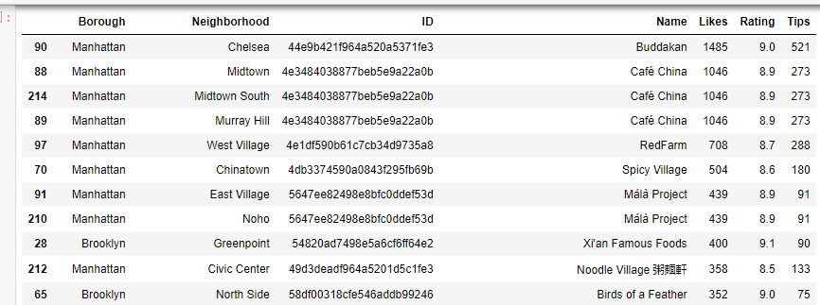

1. We will then sort Neighbourhoods and Borough the data keeping Ratings as the constraint.

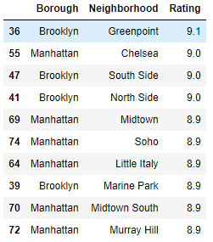

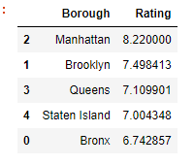

1. Next we will consider the neighbourhoods with top 20 rating to visualize on map.
2. We will join this dataset to original New York data to get longitude and latitude.

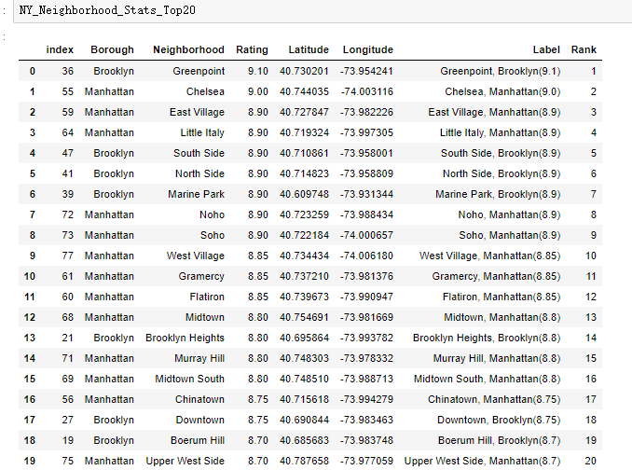

1. Finally, we will visualize the Neighbourhoods and Borough based on average Rating using python’s Folium library.

Neighbourhoods based on average rating:

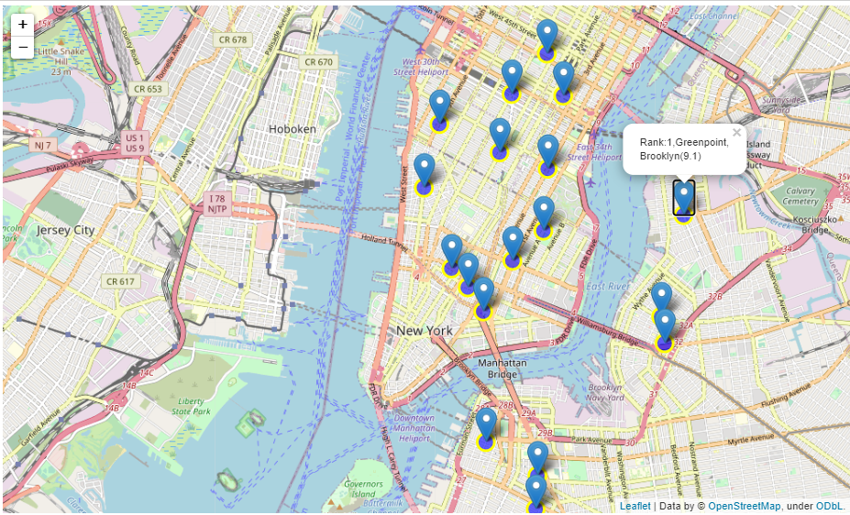

Borough based on average rating:

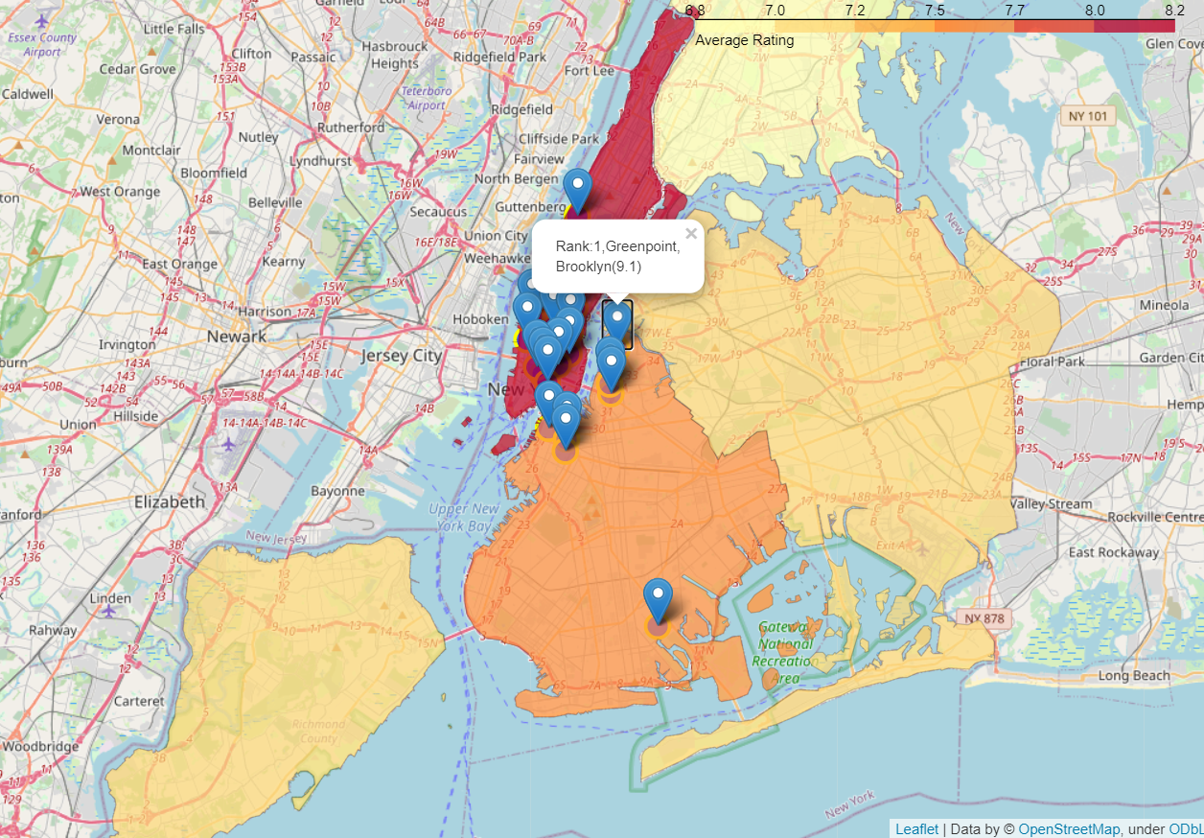

**Result:**

So now we can answer the questions asked above in the Questions section:

Answers:

1. The following location in New York City has great Chinese restaurants.

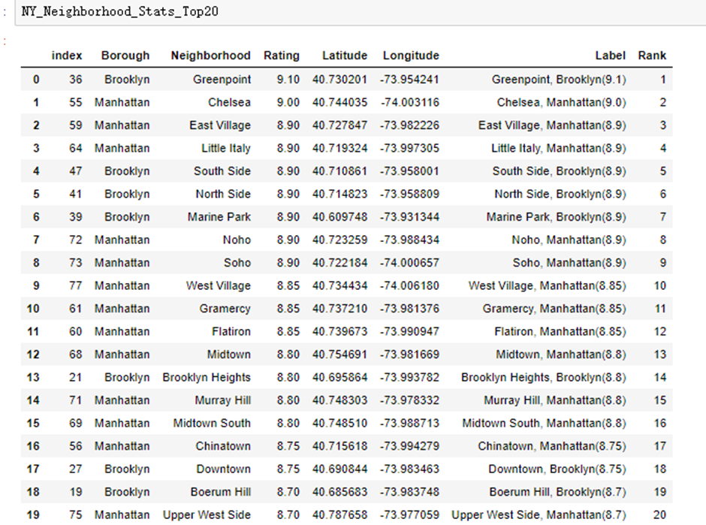

#### Greenpoint (Brooklyn), Chelsea (Manhattan), East Village (Manhattan) are some of the best neighbourhoods for Chinese cuisine.

#### Manhattan have potential Chinese Restaurant Market.

#### Bronx ranks last in average rating of Chinese Restaurants.

#### Xi'an Famous Foods in Greenpoint, Brooklyn is the best Chinese restaurant in New York City.

**Conclusion:**

There is always room for improvement and hence the above solution I have provided can also be improved for best results depending upon the data we have.